1. List the following details of each employee: employee number, last name, first name, gender, and salary.

SELECT "EMPLOYEES".emp_no,

"EMPLOYEES".last_name,

"EMPLOYEES".first_name,

"EMPLOYEES".gender,

"SALARIES".salary

from public."EMPLOYEES"

JOIN public."SALARIES"

ON "EMPLOYEES".emp_no = "SALARIES".emp_no;

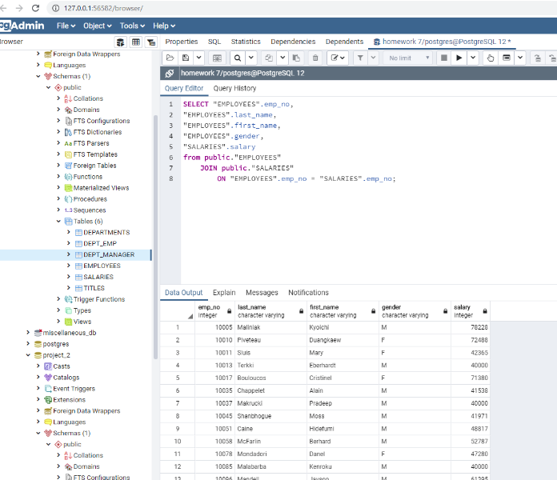

1. List employees who were hired in 1986.

SELECT first_name, last_name, hire_date

FROM "EMPLOYEES"

WHERE hire_date BETWEEN '1986-01-01' AND '1987-01-01';

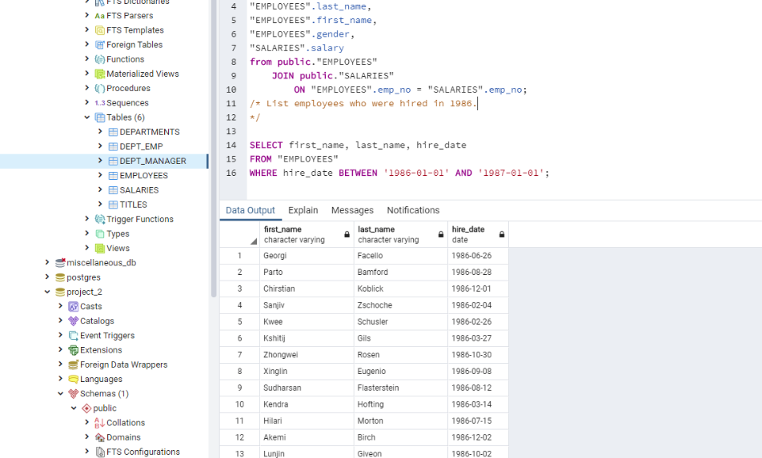

1. List the manager of each department with the following information: department number, department name, the manager's employee number, last name, first name, and start and end employment dates.

SELECT "DEPARTMENTS".dept_no,

"DEPARTMENTS".dept_name,

"DEPT_MANAGER".emp_no,

"EMPLOYEES".last_name,

"EMPLOYEES".first_name,

"DEPT_MANAGER".from_date,

"DEPT_MANAGER".to_date

from public."DEPARTMENTS"

JOIN "DEPT_MANAGER"

ON "DEPARTMENTS".dept_no = "DEPT_MANAGER".dept_no

JOIN "EMPLOYEES"

ON "DEPT_MANAGER".emp_no = "EMPLOYEES".emp_no;

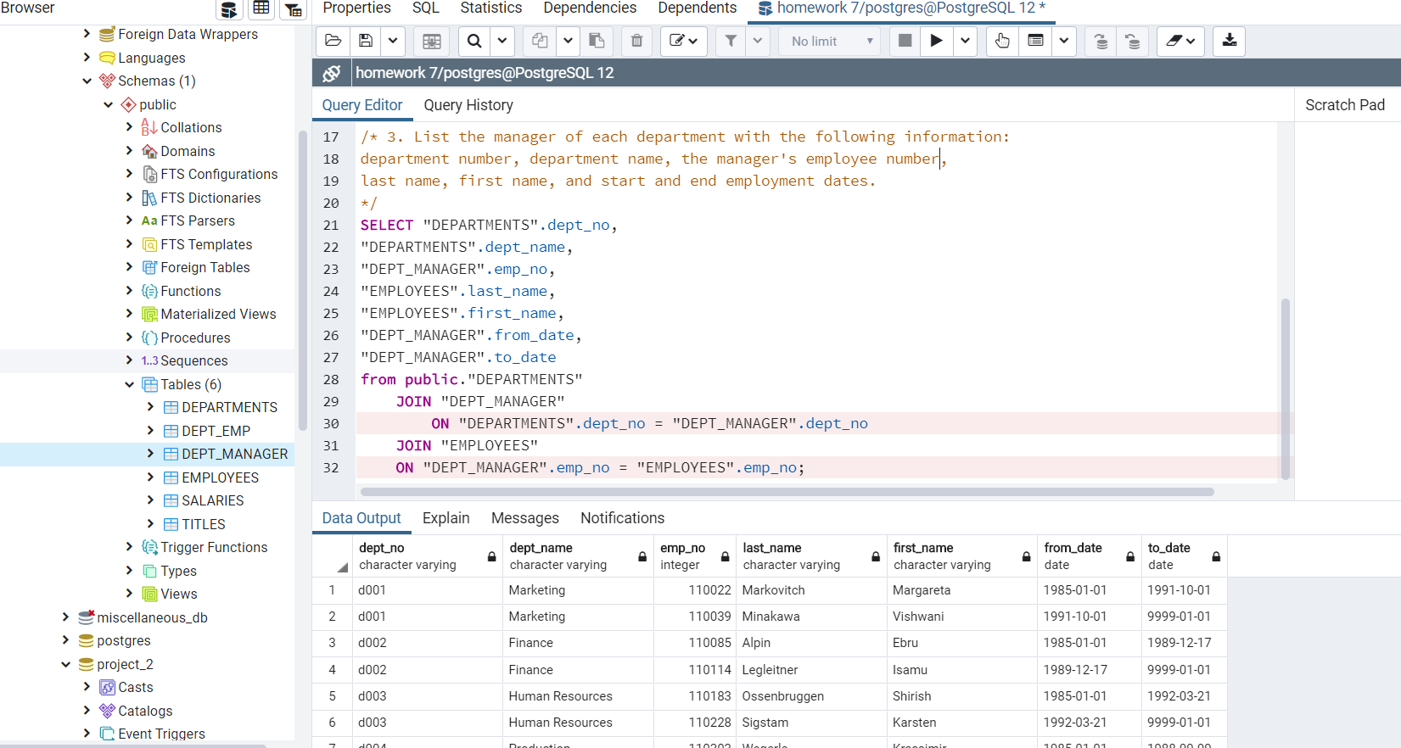

1. List the department of each employee with the following information: employee number, last name, first name, and department name.

SELECT "DEPT_EMP".emp_no,

"EMPLOYEES".last_name,

"EMPLOYEES".first_name,

"DEPARTMENTS".dept_name

from public."DEPT_EMP"

JOIN "EMPLOYEES"

ON "DEPT_EMP".emp_no = "EMPLOYEES".emp_no

JOIN "DEPARTMENTS"

ON "DEPT_EMP".dept_no = "DEPARTMENTS".dept_no;

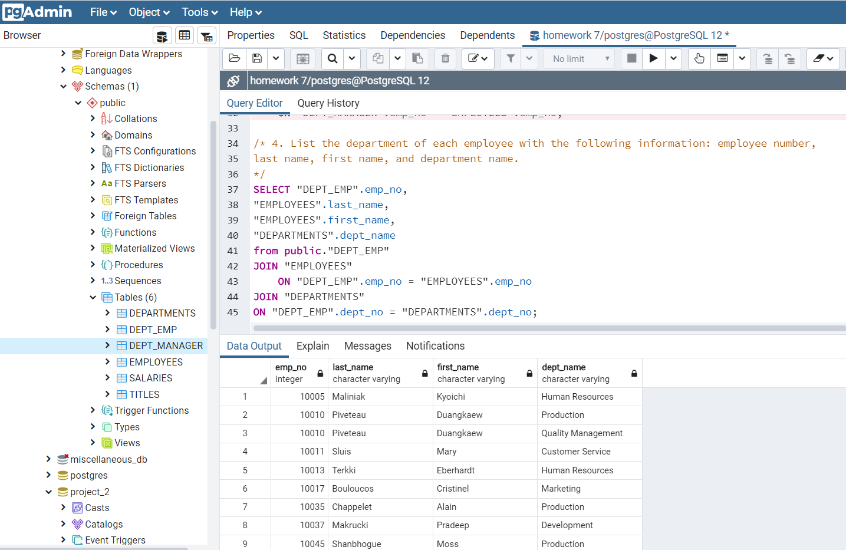

1. List all employees whose first name is "Hercules" and last names begin with "B."

SELECT first_name, last_name

FROM "EMPLOYEES"

WHERE first_name = 'Hercules'

AND last_name LIKE 'B%';

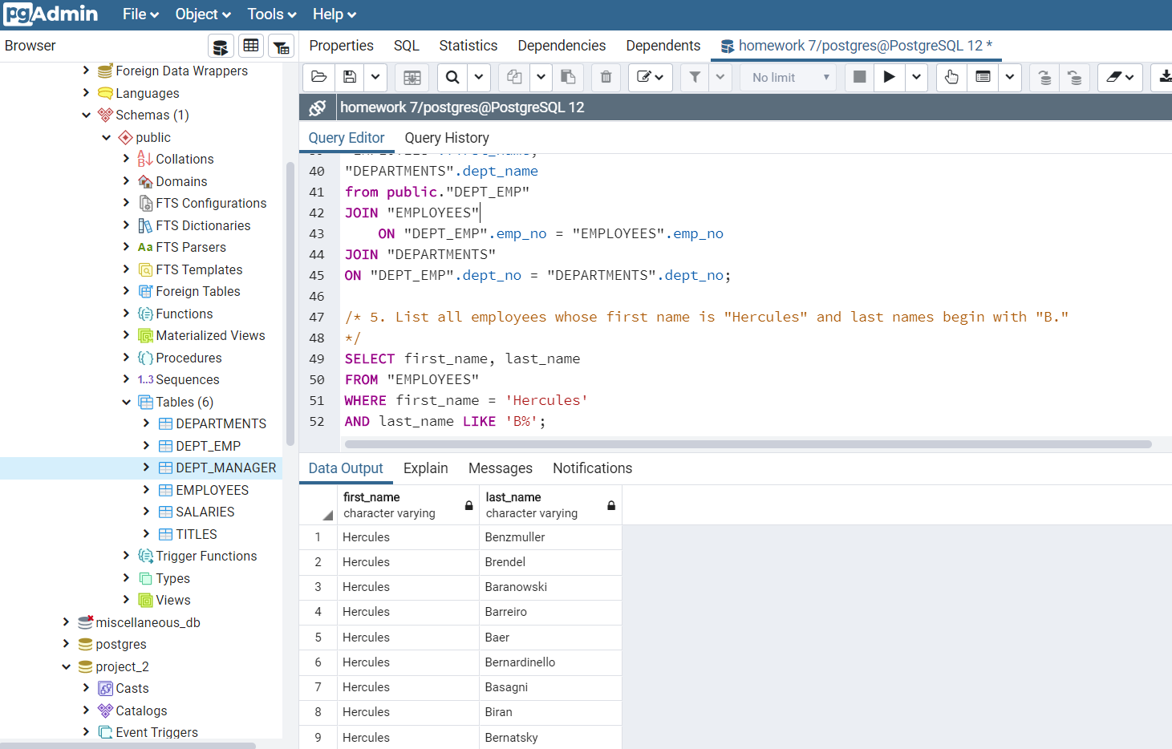

1. List all employees in the Sales department, including their employee number, last name, first name, and department name.

SELECT "DEPT_EMP".emp_no,

"EMPLOYEES".last_name,

"EMPLOYEES".first_name,

"DEPARTMENTS".dept_name

from public."DEPT_EMP"

JOIN "EMPLOYEES"

ON "DEPT_EMP".emp_no = "EMPLOYEES".emp_no

JOIN "DEPARTMENTS"

ON "DEPT_EMP".dept_no = "DEPARTMENTS".dept_no

WHERE "DEPARTMENTS".dept_name = 'Sales';

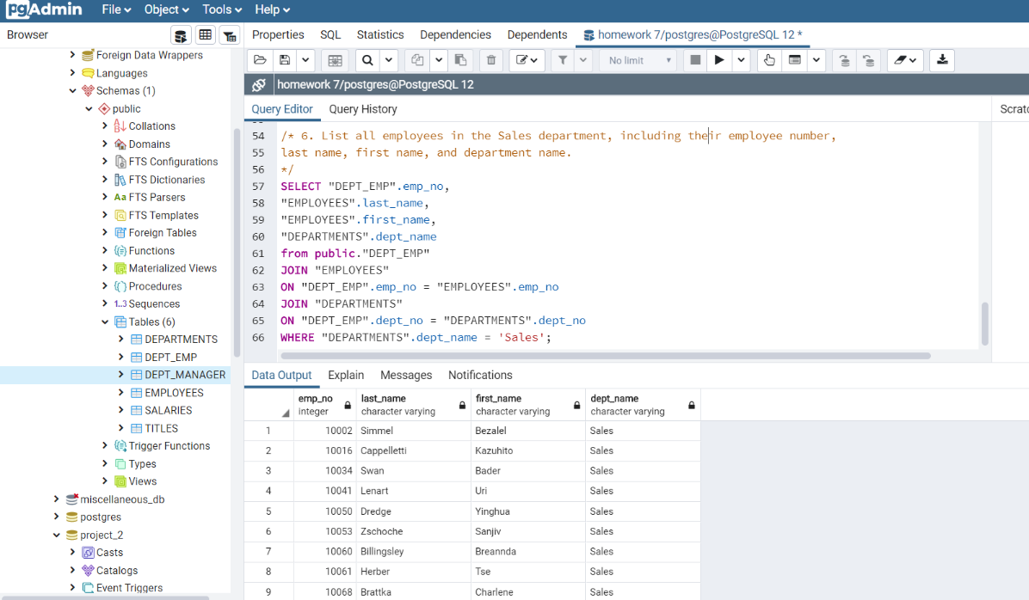

1. List all employees in the Sales and Development departments, including their employee number, last name, first name, and department name.

SELECT "DEPT_EMP".emp_no,

"EMPLOYEES".last_name,

"EMPLOYEES".first_name,

"DEPARTMENTS".dept_name

from public."DEPT_EMP"

JOIN "EMPLOYEES"

ON "DEPT_EMP".emp_no = "EMPLOYEES".emp_no

JOIN "DEPARTMENTS"

ON "DEPT_EMP".dept_no = "DEPARTMENTS".dept_no

WHERE "DEPARTMENTS".dept_name = 'Sales'

OR "DEPARTMENTS".dept_name = 'Development';

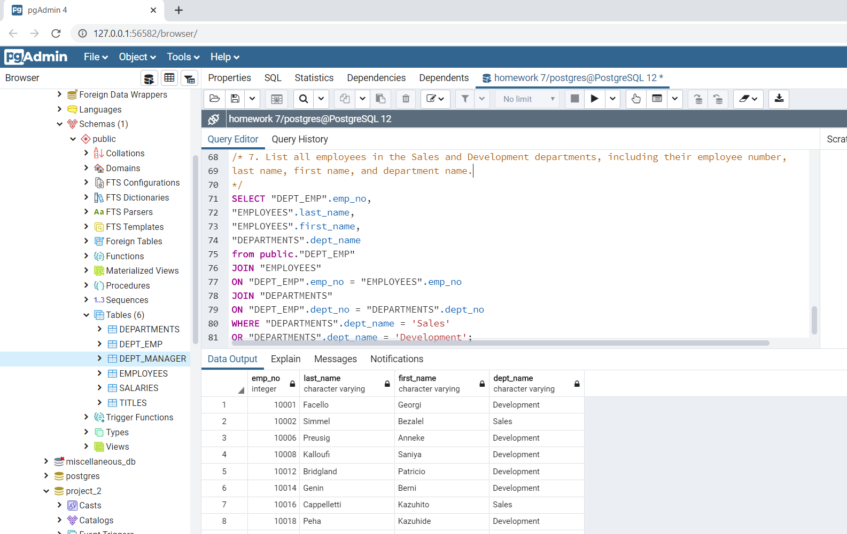

1. In descending order, list the frequency count of employee last names, i.e., how many employees share each last name.

SELECT last_name,

COUNT(last_name) AS "frequency"

from public."EMPLOYEES"

GROUP BY last_name

ORDER BY

COUNT(last_name) DESC;

